DATA UNF SAMPAI 3NF
UNF
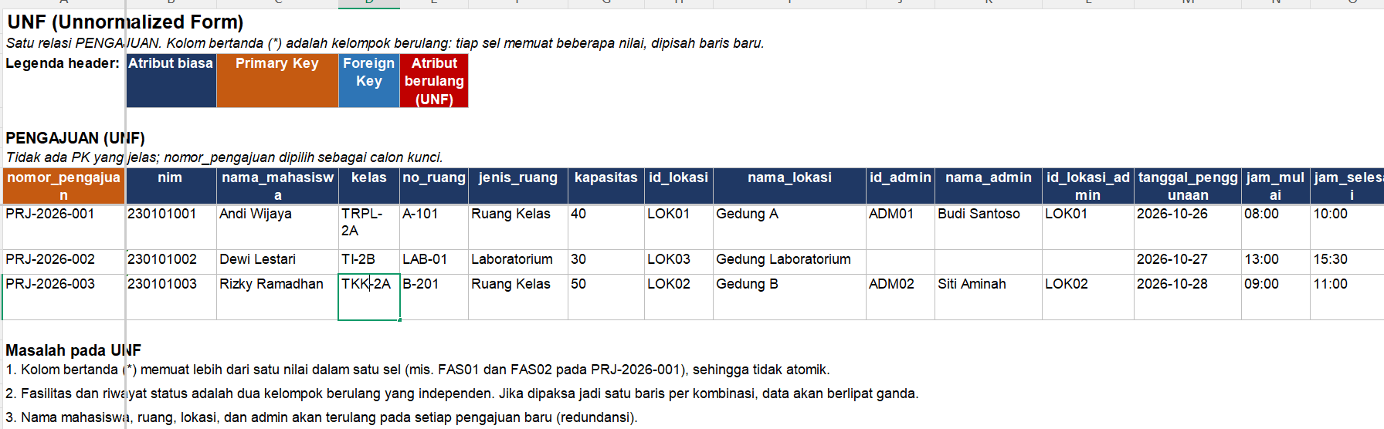
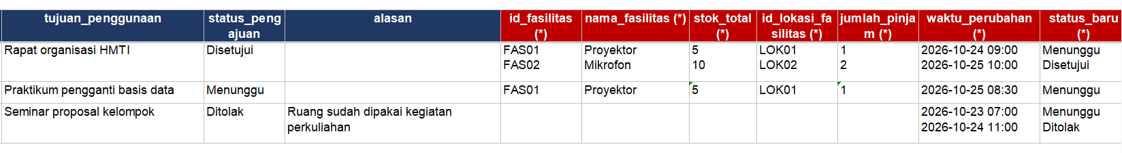
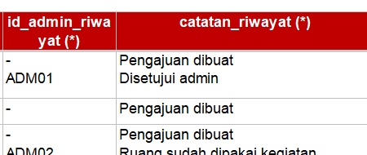

1NF
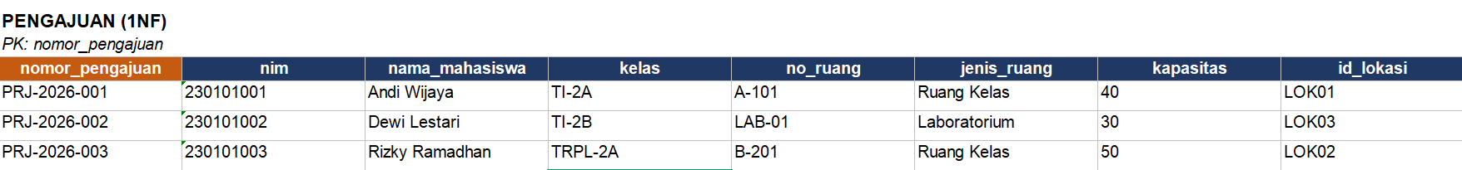
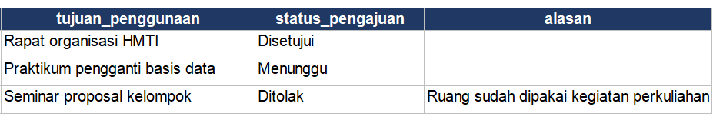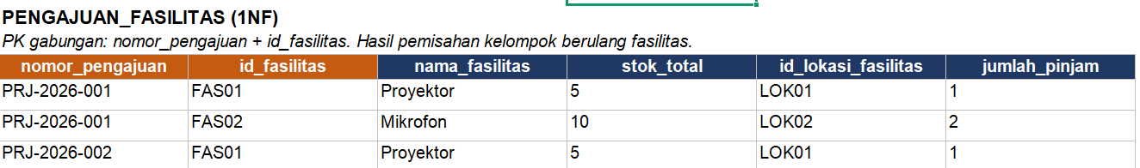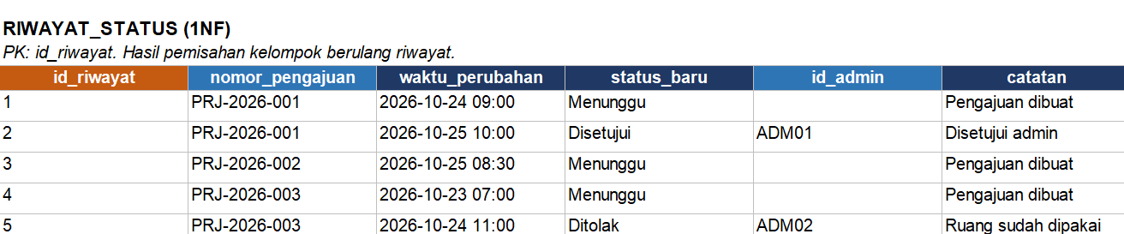

2NF
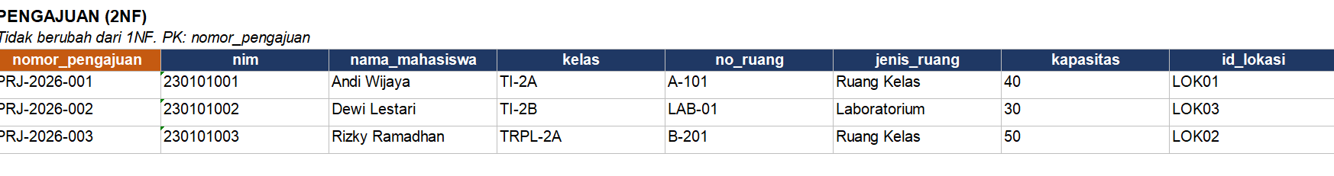
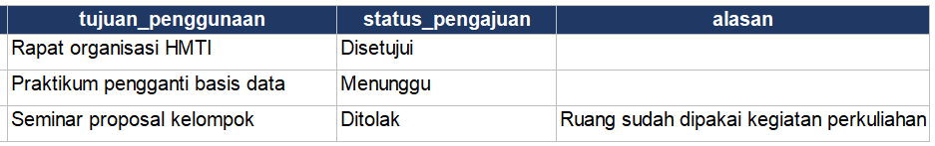
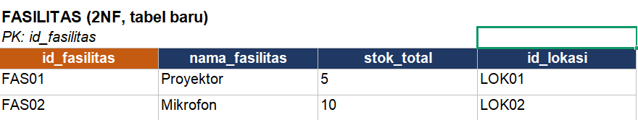
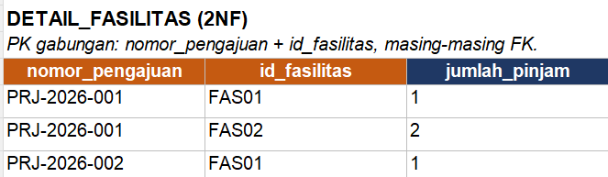
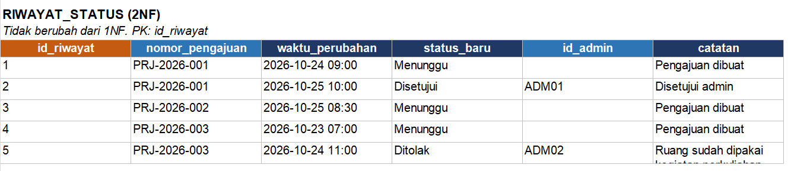

3NF
